Scenario 1

TASK 1

A new database was created and the JSON file with all the restaurants.

TASK 2

Here, the group function in aggregation was used to all the restaurants corresponding to the postcodes they are located in. The result was then saved in a view.

{

_id: "$postcode",

fieldN: {$addToSet: '$RestaurantName' }

TASK 3

For this task a CSV file was made for the data and was uploaded to the Jupiter notebook. This task can be viewed using the corresponding Jupiter notebook.

TASK 4

For this task restaurants with ratings 2 or less were filtered out. This filtered out data was exported to a separate JSON file. This JSON file was then imported in a new collection.

TASK 5

TASK 6

The average rating for the restaurants was found as below. The list of restaurants having low rating was found in task 4.

TASK 7

The names of restaurants with type of food or country in it were recovered as follows.

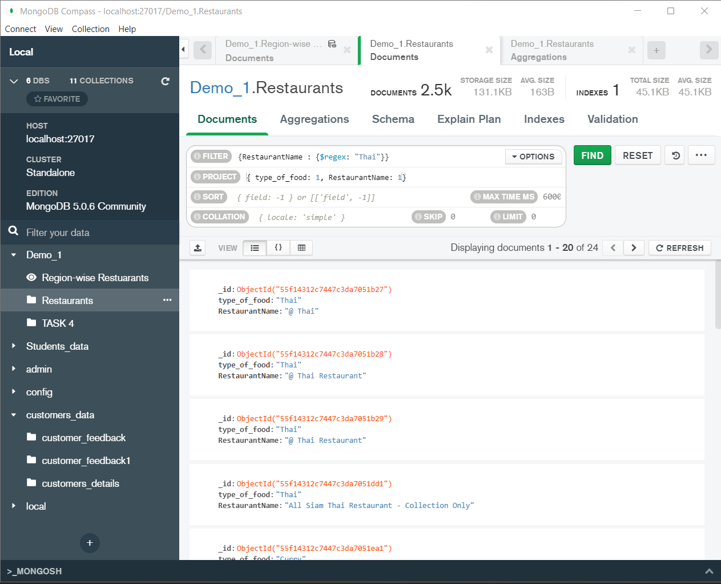

Scenario 2

TASK 1

A collection named BookData was created and the JSON file containing details of books was imported in it.

TASK 2

The required fields were displayed as shown below.

TASK 3

TASK 4

TASK 5

TASK 6

This task is same as task 4.

TASK 11

